**Field Service and Asset Tracking System**

# System Overview

# Objectives

# Scope

Work Orders

Select Multiple Users

Select Multiple Work Order Types

Set/schedule Appointments

Reference:

<https://docs.microsoft.com/en-us/dynamics365/field-service/field-service-architecture>

The most important process in Field Service is the work order process where work orders are:

Created

Scheduled to resources

Performed by field technicians

Completed and reviewed

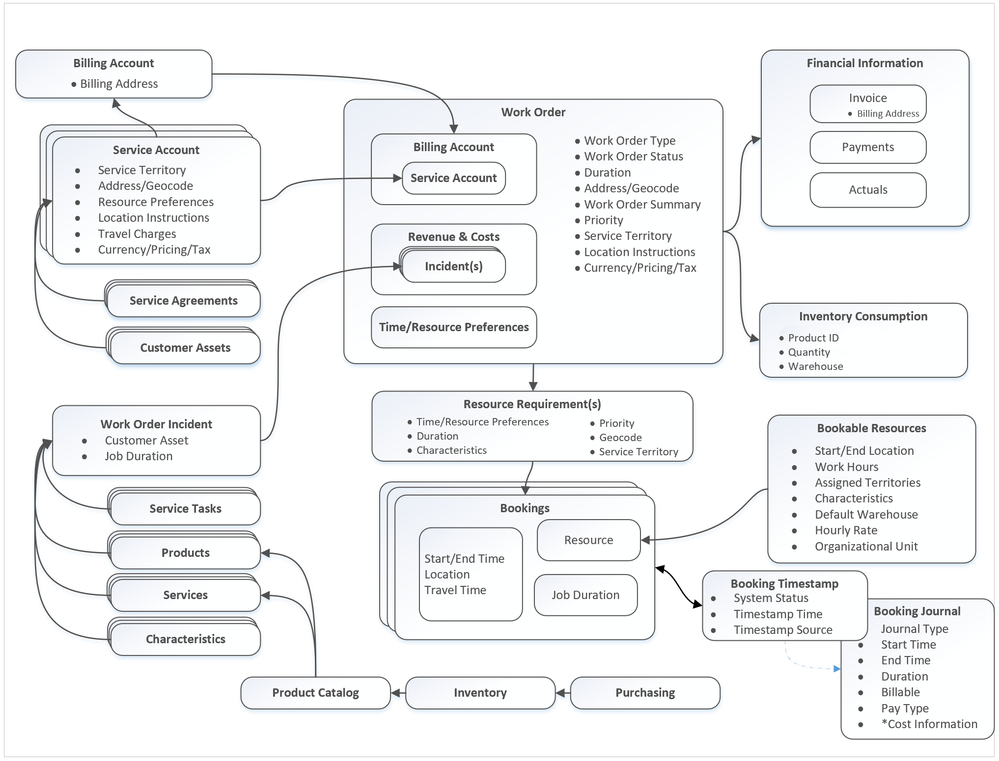

Work order lifecycle

Work order creation: A work order is created, usually from a case or opportunity

Schedule: The work order is then scheduled.

Dispatch: The work order is dispatched.

Service: The work order is performed and details are updated.

Review/Approval: The work order is reviewed and approved by a supervisor.

Invoice and inventory adjustment: Inventory adjustments are made and an invoice is generated for the corresponding account.

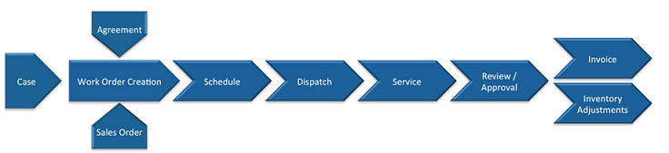

Work Order System Statuses are noted on the work order entity, marking the current point of a work order in its life cycle. They are part of the product by default and should not be edited. Work order system statuses are:

Open - Unscheduled

Open - Scheduled

Open - In Progress

Open - Completed

Closed - Posted

Closed – Canceled

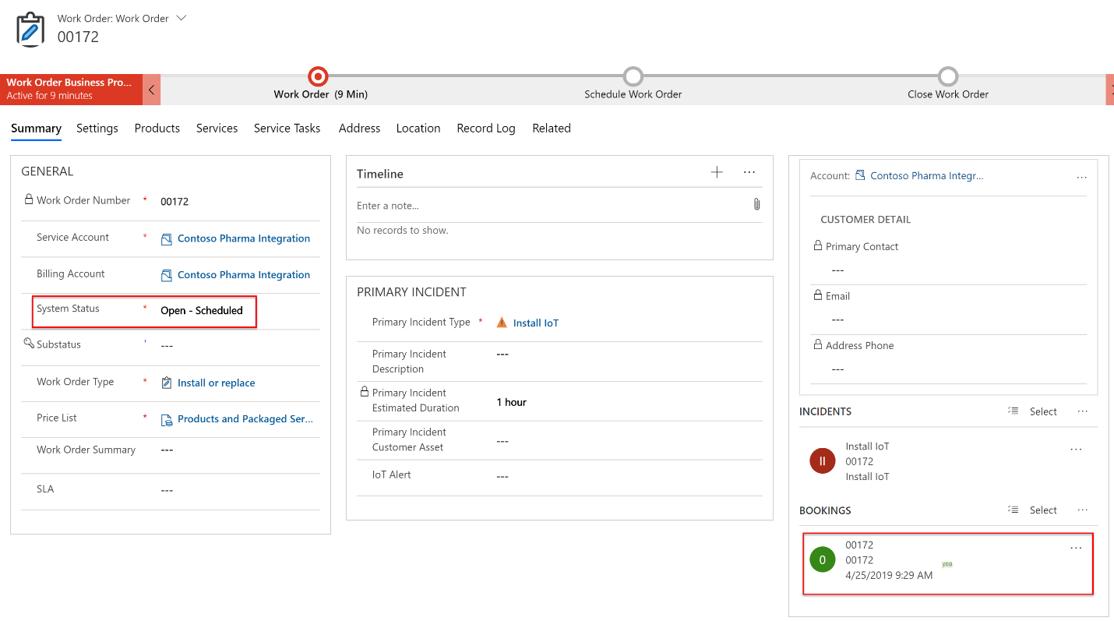

Incident types act as service templates that allow users to quickly create work orders for the most common types of jobs that your organization performs. Incident types are also used to define specific work order issues and recommended resolutions.

Where work order types define the general category of a work order (for instance: inspection, repair, or maintenance), incident types define the specific request of a work order and effectively add more details to the work order type.

For example, an incident type can be:

A specific error code on a machine ("Error code 0048").

A common customer complaint or request ("The building temperature is too hot").

A specific procedure ("Perform stress test").

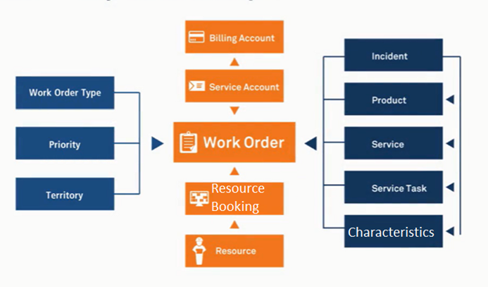

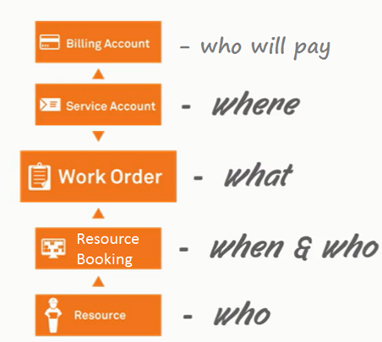

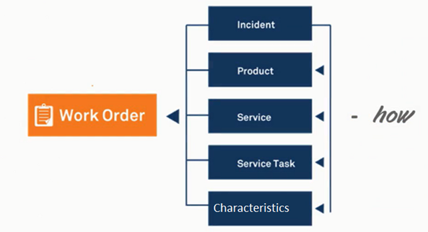

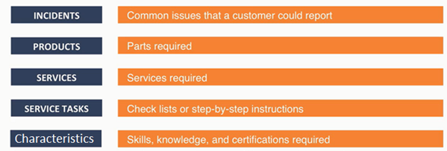

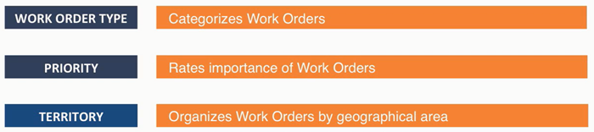

Reference:

<https://help.salesforce.com/articleView?id=sf.wo_fields.htm&type=5>

| FIELD | DESCRIPTION |
| --- | --- |
| Account | The account associated with the work order. |
| Address | The compound form of the address where the work order is completed. The work order’s service appointments and line items inherit its address, though the address on line items can be updated. |
| Asset | The asset associated with the work order. |
| Business Hours | The business hours associated with the work order. |
| Case | The case associated with the work order. |
| City | The city where the work order is completed. Maximum length is 40 characters. |
| Contact | The contact associated with the work order. |
| Country | The country where the work order is completed. Maximum length is 80 characters. |
| Currency ISO Code | Three-letter currency code. Available only if the multicurrency feature is enabled. |
| Description | The description of the work order. We recommend describing the steps a user takes to mark the work order Completed. |
| Discount | (Read Only) The weighted average of the discounts on all line items on the work order. It can be any positive number up to 100. |
| Duration | The estimated time required to complete the work order. Specify the duration unit in the Duration Type field.  Note  NOTE Work order duration and work order line item duration are independent of each other. If you want work order duration to automatically show the sum of the work order line items’ duration, replace the Duration field on work orders with a custom roll-up summary field. |
| DurationInMinutes | The estimated time required to complete the work order, in minutes. This field is for internal use. |
| Duration Type | The unit of the duration: Minutes or Hours. |
| End Date | The date when the work order is completed. This field is blank unless you set up automation to configure it. For a sample workflow rule that configures the Start Date field (a similar field), see Start Date. |
| Entitlement | The entitlement associated with the work order. |
| Entitlement Process End Time | The time the work order exits an entitlement process. If an entitlement process applies to a work order, this field appears. |
| Entitlement Process Start Time | The time the work order entered an entitlement process. If an entitlement process applies to a work order, this field appears. |
| Generated from maintenance plan | (Read Only) Indicates that the work order was generated from a maintenance plan rather than manually created.  Note  NOTE This option is deselected for work orders that were generated from maintenance plans before Summer ’18. |
| Geocode Accuracy | The level of accuracy of a location’s geographical coordinates compared with its physical address. A geocoding service typically provides this value based on the address’s latitude and longitude coordinates. |
| Grand Total | (Read Only) The total price of the work order with tax added. |
| Is Closed | Indicates whether the work order is closed.  Tip  TIP Use this field to report on closed versus open work orders. |
| Last Modified Date | The date when the work order was last modified. |
| Last Viewed Date | The date when the work order was last viewed. |
| Latitude | Used with Longitude to specify the precise geolocation of the address where the work order is completed. Acceptable values are numbers between –90 and 90 with up to 15 decimal places. |
| Line Items | (Read Only) The number of work order line items on the work order. |
| Location | The location associated with the work order. For example, a work site. |
| Longitude | Used with Latitude to specify the precise geolocation of the address where the work order is completed. Acceptable values are numbers between –180 and 180 with up to 15 decimal places. |
| Maintenance Plan | The maintenance plan associated with the work order. When the work order is auto-generated from a maintenance plan, this field automatically lists the related plan. |
| Milestone Status | A milestone is a step in an entitlement process. It can have one of three statuses: Compliant, Open Violation, and Closed Violation. If an entitlement process applies to a work order, this field appears. To learn more, see [Milestone Statuses](https://help.salesforce.com/articleView?id=entitlements_milestones_statuses.htm&type=5&language=en_US#entitlements_milestones_statuses). |
| Milestone Status Icon | An icon that corresponds to the milestone status.   * Milestone completed icon Compliant * Milestone open violation icon Open Violation * Closed violation icon Closed Violation |
| Minimum Crew Size | The minimum crew size allowed for a crew assigned to the work order.  If you’re not using the Field Service managed package, this field serves as a suggestion rather than a rule. If you’re using the managed package, the scheduling optimizer counts the number of service crew members on a service crew to determine whether it fits a work order’s minimum crew size requirement. |
| Owner | The work order’s assigned owner. |
| Parent Work Order | The work order’s parent work order, if it has one.  Tip  TIP View, create, and delete a work order’s child work orders in the Child Work Orders related list. |
| Postal Code | The postal code where the work order is completed. Maximum length is 20 characters. |
| Price Book | The price book associated with the work order. Adding a price book to the work order lets you assign different price book entries (products) to the work order’s line items. This field is only available if products are enabled. |
| Priority | The priority of the work order. The picklist includes the following values, which can be customized:   * Low * Medium * High * Critical |
| Product Service Campaign | The product service campaign associated with the work order. |
| Product Service Campaign Item | The product service campaign item associated with the work order. |
| Recommended Crew Size | The recommended number of people on the service crew assigned to the work order. |
| Record Type | The record type associated with the work type. |
| Return Order | The return order associated with the work order. |
| Return Order Line Item | The return order line item associated with the work order. |
| Root Work Order | (Read Only) The top-level work order in a work order hierarchy. Depending on where a work order lies in the hierarchy, its root can be the same as its parent. |
| Service Appointment Count | The number of service appointments on the work order. |
| Service Contract | The service contract associated with the work order. |
| Service Report Language | The language used for all service reports and service report previews created for the work order, its service appointments, and its work order line items and their service appointments. If the field is blank, service reports are generated in the default language in Salesforce of the person creating the report.  To appear as an option in the Service Report Language field, a language must be set up in Translation Workbench or be one of the Salesforce 18 [fully supported languages](https://help.salesforce.com/articleView?id=faq_getstart_what_languages_does.htm&type=5&language=en_US). Service report field names are translated, but rich text field names, service report section names, and text field values such as service notes aren’t translated. |
| Service Report Template | The service report template that the work order’s service reports uses.  If you don’t specify a service report template on a work order, it uses the service report template listed on its work type. If the work type doesn’t list a template or no work type is specified, the work order uses the default service report template.  Note  NOTE This field stays blank unless you update it on the work order. So to find out which template the work order’s service reports uses, check its work type. |
| Service Territory | The service territory where the work order is taking place. |
| Start Date | The date when the work order goes into effect. This field is blank unless you set up automation to populate it. See the example for a workflow rule that configures this field. |
| State | The state where the work order is completed. Maximum length is 80 characters. |
| Status | The status of the work order. The picklist includes the following values, which can be customized:   * New—Work order was created, but there hasn’t yet been any activity. * In Progress—Work has begun. * On Hold—Work is paused. * Completed—Work is complete. * Cannot Complete—Work couldn’t be completed. * Closed—All work and associated activity is complete. * Canceled—Work is canceled, typically before any work began.   Changing a work order’s status doesn’t affect the status of its work order line items or associated service appointments. |
| Status Category | The category that each status value falls into. The Status Category field has eight default values: seven values that are identical to the default Status values, and a None value for statuses without a status category.  If you create custom Status values, you must indicate which category it belongs to. For example, if you create a Waiting for Response value, you can decide that it belongs in the On Hold category.  To learn which processes reference Status Category, see [How are Status Categories Used?](https://help.salesforce.com/articleView?id=fs_status_categories.htm&type=5) |
| Stopped | Indicates that the milestone countdown has been paused. |
| Stopped Since | The time the milestone countdown was paused. |
| Street | The street number and name where the work order is completed. |
| Subject | The subject of the work order. Describe the nature and purpose of the job to be completed. For example: annual on-site well maintenance. The maximum length is 255 characters. |
| Subtotal | (Read Only) The total of the work order line items’ subtotals before discounts and taxes are applied. |
| Suggested Maintenance Date | The suggested date that the work order is completed. When the work order is generated from a maintenance plan, this field is automatically populated based on the maintenance plan’s settings. |
| Tax | The total tax on the work order. For example, in a work order whose total price is $100, enter $10 to apply a 10 percent tax. You can enter a number with or without the currency symbol and you can use up to two decimal places. |
| Total Price | (Read Only) The total of the work order line items’ price after discounts but before tax is added. |
| Work Order Number | An autogenerated number that identifies the work order. |
| Work Type | The work type associated with the work order. When a work type is selected, the work order automatically inherits the work type’s Duration, Duration Type, and required skills. |

Service appointments come with the following statuses to represent stages in their life cycle.

None

Scheduled

Dispatched

In Progress

Completed

Cannot Complete

Canceled